Theme Development

07 Theme dev

Place holder Screenshot

Tony Evans

**Create Pages**

See next page for screenshots of what your page should look like

In this folder you can see the following:

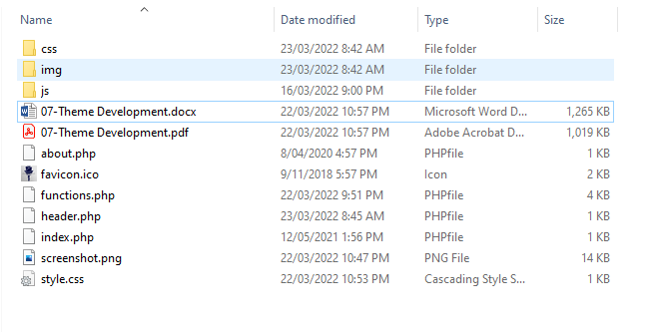

The files in this folder should look like 06 Theme Development. The root folder style.css file is still the same but just updated for the theme name for 07.

This tutorial will be creating pages and linking to the menu.

# Add Pages

To add pages that are not in the default action of the Administration window such as adding “Sample page” to the menu, are a little different to set up.

If you investigate the folder for this theme, notice that there is a page called “about.php”.

Open the file in Notepad++ and look at the coding.

This page contains some coding that will be our “About” page.

To start adding this to the menu and view the page open the admin window to the “menus”.

Notice that there are no pages added to the menu. To do this we will need to create a page called “About”.

Click on the menu item “Pages”.

Click “Add New”.

Type in “About” and the click “Publish”.

The page has been published.

Now go back to the “**Appearance > Menus**” and you should now see the “About” page added.

Now add the page to the menu. Make sure that you click the “My Custom Menu” to add it to.

Don’t forget to save the menu.

Go to the page view to see if it has been added to the menu.

The “About” has been added to the menu. Click on the link to see if it works.

You will find at this point the link does not work and only refreshes the current page.

Now to add that page that we have called “about.php”. To do this you will need to change the name of the file. Change it to “page-about.php”.

Now go back to the browser window and then click the link.

You should see the “About” page show.

You now have a way of adding pages just by naming them to “page-“ in front to the name you want to call it.

Add another page called “page-contact” into your folder by copying the about page and renaming.

Follow the previous steps to create the menu item and then it should appear in the menu and the link will go to your page.

View menu items and add the page.

Don’t forget to save.

Visit the page and check the menu.

Click the link and you should see the new contact page.

Continue working on your theme.